The University of Virginia (University or UVA) invites highly qualified Architectural/ Engineering (A/E) firms to submit a Letter of Interest/ Statement of Qualifications and associated supporting materials for consideration in the selection of a consultant team to provide planning, architectural, and engineering design services for a planning study of the Darden Faculty Office Building in accordance with the latest version of the UVA Higher Education Capital Outlay Manual (HECOM). The first phase of the project will be a planning study. Upon successful completion of the study, the University may in its sole discretion elect to retain the selected firm for full design and construction services for any or all phases of the future project.

**Purpose & Program** **Background:**

The University of Virginia Darden School of Business is routinely ranked as the world’s best educational experience. As the center of that accolade is Darden’s faculty, ranked for decades as the best in the world among business schools. Darden expects much from our faculty: excellent student-centered instruction, world-class research, advancing pedagogy through teaching cases and other course materials, and speaking to and influencing the world of practice.

To deliver on these expectations, Darden’s faculty require spaces that allow for a mix of both individual and collaborative workspaces enabled by technology. Faculty need spaces to interact with many stakeholders and to work together on projects and research. They also require dynamic spaces to host outside academic speakers for seminars, to meet with students and alumni, and to host external executives and other business and organizational leaders. Additionally, renovation is required to accommodate the approximate 50% growth of the Darden faculty that has occurred, particularly in the past decade.

The Darden Faculty Office Building (FOB), built over 25 years ago, does not meet many of these necessary, contemporary dimensions. Largely a hoteling space for faculty offices, the Darden FOB features long hallways with no natural light and few common, collaboration spaces. Rather than an inspiring place to conduct their work, faculty find the FOB to be an inferior space to alternatives such as working from home. For a school that prides itself on a vibrant community, the current FOB is a strategic disadvantage and critical shortcoming of the Darden School.

Darden aspires to provide a faculty workplace that reinforces and enhances Darden’s position as a vibrant, diverse community engaging in scholarship and student-centered learning. The Darden Faculty Office Building Renovation will aim to rectify these weaknesses by renovating the existing building to be consistent with modern standards – and peer business schools – for openness, collaboration, technology, and impact.

**Project Drivers:**

The initial phase of this Project will focus on developing and evaluating design options, schedule, and budget to renovate the existing Darden Faculty Office Building. Key considerations include an increase in faculty offices – critical to accommodate the faculty growth that has occurred at Darden. More importantly, Darden is seeking design options that enhance the faculty experience by providing an inspiring new building featuring natural light, innovative collaborative spaces, and dynamic meeting rooms.

The current initial scope of work for the A/E firm includes the following:

* **Planning Study** to renovate existing Darden Faculty Office Building
* **Project Program & Program Verification** to include faculty offices, seminar rooms, collaborative workspaces (both indoor and thru the integration of the existing building outdoor courtyards and upper-floor porches), and meeting rooms
* **Preliminary Phasing Studies** to inform cost and schedule duration of options evaluated (assuming development of 2-3 options)
* **Engineering Studies** to identify systems required for renovation (including narratives and diagrams to inform cost and schedule impact)
* **Cost Estimating Services** to establish Construction Cost Estimates for renovation
* **Meetings/ Presentations**:
  + Steering Committee
  + Focus Groups
  + Working Group
  + Additional Ad-hoc Meetings as Necessary

**Criteria in Support of Strategic Plan:**

This Project is in direct support of the University’s 2030 Strategic Plan to strengthen our foundation supporting students, faculty, and staff by enhancing the faculty experience to be consistent with modern standards.

**Project Status:**

This Request for Qualifications follows the Board of Visitors September 2022 approval of the Darden School of Business Master Plan including renovations to the Faculty Office Building.

**Project Site:**

The Darden School of Business is located within the University’s North Grounds. Constructed in 1996, Darden is anchored by a central Commons building and flanked by matching ranges of academic and faculty pavilions to the south and a library and auditorium to the north. The Faculty Office Building is situated to the southeast along Darden Boulevard.

**Qualifications:**

The selected firm will have a proven record of design excellence, with a demonstrated ability to bring ideas, expertise, and imagination to a complex building project. The design team must demonstrate considerable experience in the planning, designing, documenting, and construction administration of projects of comparable scale and complexity in a higher education setting. Experience in obtaining LEED certification and familiarity with HECOM will be required.

**Selection Process Schedule:**

|  |  |
| --- | --- |
| * RFQ Advertised………… | December 13, 2024 |
| * Response Deadline……. | January 15, 2025 by 2:00 pm** |
| * Shortlist Notified………. | January 24, 2025 |
| * RFPs Issued ………….... | January 31, 2025 |
| * Preproposal Site Visit…. | TBD |
| * Proposal Deadline………. | February 28, 2025, by 2:00 pm** |
| * Interviews………………... | March 10, 2025 |

***\*\* The University will not accept late submissions for any reason.***

**Submittal Requirements & Process:**

Submitted material shall be electronic format only. Interested firms may send **one (1)** thumb drive containing your submittal in PDF format, OR an email containing the submittal if size permits, OR send a link to a file storage system. The digital copy should be one unlocked PDF file of the entire submission. The submittal is to include the following:

1. Letter of Interest addressed to the Selection Committee that is no longer than two (2) pages in length, and which states specifically the firm’s successful experience in planning and designing very similar facilities in campus and/or other similar settings.
2. Statement of Qualifications using the Office of Contract Administration Services (OCAS) standard form which the firm can obtain from the OCAS website at:

<https://www.fm.virginia.edu/docs/fpc/contractadmin/SOQ-form.pdf>.

The email address provided should be for the person who will receive information regarding this RFQ. No general firm or marketing emails please.

1. Representative images of the projects listed under “Recent Project Experience” in the Statement of Qualifications.
2. Standard forms AE-1 through AE-6 which are available at:

<https://dgs.virginia.gov/globalassets/business-units/bcom/documents/forms/dgs-30-004_03-19_ae_data_forms.xlsx>

If proposal is a joint venture or association or two or more firms, UVA requires forms AE-1 through AE-6 for each firm, with the proposed division of A/E services clearly indicated by firm and by individual staff members.

1. Firms can list Subconsultants on the AE-1 or firms can submit an AE-2 for them, but firms should not submit any other AE forms for Subconsultants at this time.
2. Current references and current contact information for each project (five-project minimum) featured in AE forms above. Include contact information for an Owner’s Representative, a User Client, and a Construction Manager (CM) for each project.

Submittals will be evaluated based on the demonstrated significant experience of the firm and its proposed personnel with similar facilities and projects within a higher education setting; the ability to meet specific Project objectives, e.g., budget, schedule, quality, etc.; successful experience with HECOM; experience in design with CM/ Subcontractor participation; experience with completion of sequential trade packages for construction; and other criteria as the Screening Committee may determine. Subsequently, the shortlisted firms will receive a detailed Request for Proposal (RFP) and the University will invite them to present a more detailed response and make an oral presentation.

The University must receive the above submission materials according to the schedule above at the following address:

University of Virginia

Capital Construction & Renovations, Office of Contract Administration Services

Attention:  Bruce Jackson

1571 Pratt Drive, Facilities Management Shop #2

Charlottesville, VA 22904

**Mailing address:**

**P.O. Box 400735**

**Charlottesville, VA 22904-4735**

**Questions: 434-924-6387or** [**brj2n@virginia.edu**](mailto:brj2n@virginia.edu)

Please do not contact the Project Manager or others at the University regarding this Project. Firms should submit all questions and correspondence regarding this procurement through Bruce Jackson in the Office of Contract Administration Services.

A copy of this Request for Qualifications is available on the Capital Construction & Renovations, Office of Contract Administration Services website at:

<https://www.fm.virginia.edu/depts/fpc/contractadmin/advertisements.html>

The University will require the successful firm to have a license to do business in Virginia and be able to demonstrate professional registration.

**eVA Business to Government Vendor Registration:**

The eVA Internet electronic procurement solution, web site portal <https://www.eva.virginia.gov/>, is the Commonwealth of Virginia’s comprehensive electronic procurement system. The portal is the gateway for firms to conduct business with state agencies and public bodies. The State expects all agencies and public bodies to use eVA. The State encourages all firms desiring to provide goods and/or services in the Commonwealth to participate in eVA. The University requires selected firms to register in eVA prior to the University making an award.

The University will consider the firm’s past and proposed participation by “SWaM” firms in the evaluation of proposals including Minority-Owned (M), Women-Owned (W), Micro (O), Service-Disabled Veteran (SDV), Small Business (S), Employment Service Organization (ESO), (8a), Economically Disadvantaged Woman Owned Small Business (EDWOSB), and Federal Service-Disabled Veteran (FSDV) Businesses. SWaM firms must register with and obtain certification from the Department of Small Business & Supplier Diversity (SBSD) in Richmond. Assistance is available for registration. The University requires quarterly reporting of expenditures to SWaM consulting firms or suppliers used in this contract by the selected firms.

**Appendix A**

**Image 1:** Proximity map showing the location of Darden in relation to Central Grounds

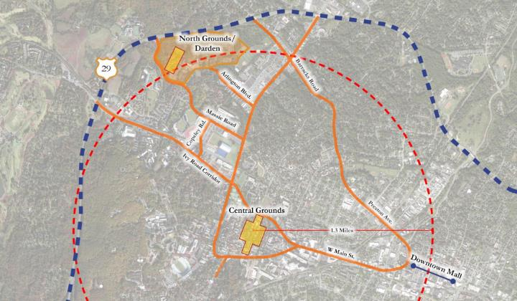

**Image 2:** Existing Darden Grounds Plan highlighting the Darden Faculty Office Building

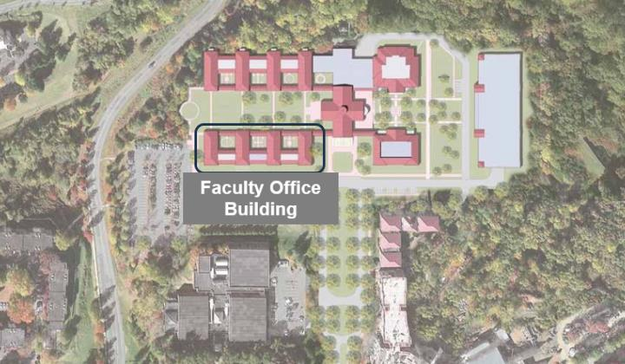

**Image 3:** Darden Faculty Office Building – Existing Level 1 Floor Plan

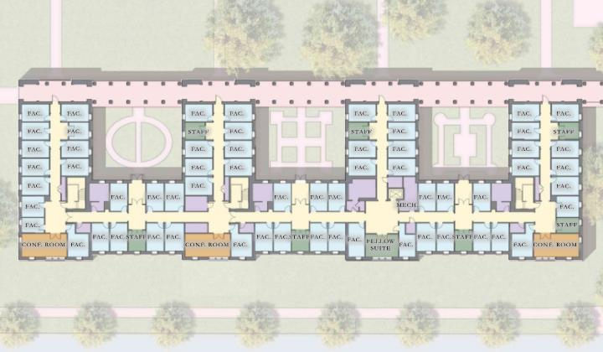

**Image 4:** Darden Faculty Office Building – Existing Level 2 Floor Plan

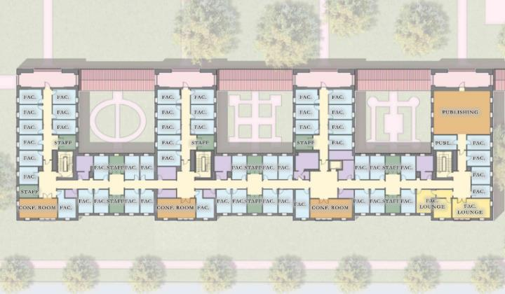

**Image 5:** Aerial rendering of existing Darden Faculty Office Building

